School of Computer Science

# University of Petroleum and Energy Studies



**MINOR - 2 PROJECT REPORT**

**ON**

**Mentor-Matrix**

(Connect Portal)

|  |  |  |  |
| --- | --- | --- | --- |
| **NAME** | **SAP ID** | **SPECIALIZATION** | **BATCH** |
| Eshan Singh | 500091330 | CSF | B01 |

# CANDIDATE’S DECLARATION

We hereby certify that the project work entitled **“Mentor-Matrix: Connect Portal”** in partial fulfillment of the requirements for the award of the Degree of BACHELOR OF TECHNOLOGY in COMPUTER SCIENCE AND ENGINEERING with specialization in DevOps, submitted to Cybernetics Cluster, School of Computer Science, University of Petroleum & Energy Studies, Dehradun, is an authentic record of my/ our work carried out during a period from *Jan, 2024 to May, 2024* under the supervision of **Mr. Amit Verma**

### , Professor.

The matter presented in this project has not been submitted by me/us for the award of any other degree of this or any other University.

Eshan Singh

R2142210303

This is to certify that the above statement made by the candidate is correct to the best of my knowledge.

**Table of contents**

|  |  |  |
| --- | --- | --- |
| Sr. No. | Title | Pg. No. |
| 1 | Project title | 1 |
| 2 | Abstract | 1 |
| 3 | Introduction | 1 |
| 4 | Literature review | 2 |
| 5 | Problem statement | 3 |
| 6 | Objectives | 3 |
| 7 | Methodology | 4 |
| 8 | Technological Stack | 6-7 |
| 9 | DataStructures | 7 |
| 10 | Algorithms | 8 |
| 11 | Application Areas | 19 |
| 12 | SWOT Analysis | 19-20 |
| 13 | PERT Chart | 20 |
| 14 | References | 21 |

**Table of figures**

|  |  |  |
| --- | --- | --- |
| Fig no. | Title | Pg. no. |
| 1.1 | DataFlow Diagram | 5 |
| 1.2 | Activity workflow diagram | 9 |
| 1.3 | Use case diagram | 10 |
| 2.1 | Welcome page | 11 |
| 2.2 | Login page | 12 |
| 2.3 | Landing page | 13 |
| 2.4 | Mentor List Screen | 14 |
| 2.5 | Mentor Detail Screen | 15 |
| 2.6 | Schedule | 16 |
| 2.7 | Announcement Page | 17 |
| 2.8 | Notification Page | 18 |
| 3.1 | PERT chart | 20 |

**REPORT (2024-25)**

# Project Title

Mentor Matrix-portal designed to revolutionize the way teachers connect with students.

# Abstract

Mentor Matrix revolutionizes education by effortlessly linking students with experienced mentors, supporting educators, and simplifying scheduling. Detailed teacher profiles showcase expertise, qualifications, and ongoing projects for ideal mentorship matches. User-friendly scheduling tools ensure students always know when mentors are available, removing guesswork. Additionally, Mentor Matrix provides teachers a platform to highlight their skills, interact with students, and manage workload effectively. Streamlined administration allows teachers to concentrate on guiding and motivating students. This initiative pledges to enhance education through stronger connections, improved communication, and empowerment for both students and teachers.

# Introduction

A web portal that seamlessly connects students with qualified mentors, empowers teachers to showcase their skills, and simplifies scheduling hassles. Introducing Mentor Matrix, a groundbreaking project designed to unlock educational potential for everyone.

What sets Mentor Matrix apart?

**Clear & Concise Profiles:** Explore detailed profiles of teachers, featuring their areas of expertise, verified qualifications, and ongoing mentoring projects. Find the perfect mentor match with ease.

**Streamlined Scheduling:** Teachers say goodbye to scheduling struggles! They can effortlessly upload and manage their availability using intuitive spreadsheets, ensuring students always know their "office hours."

**Dynamic Availability Mapping:** No more wondering where your mentor is. Mentor Matrix maps their availability seamlessly based on their schedule, eliminating guesswork and optimizing connections. Mentor Matrix isn't just about connections; it's about empowerment and efficiency.

**Teacher Spotlight:** Let your expertise shine! Showcase your unique skills, engage with students, and manage your workload with ease, all within one central platform. Streamlined

**Administration:** Reduce paperwork and manual tasks. Mentor Matrix helps teachers focus on what matters most - guiding and inspiring students. This project has the potential to transform the educational landscape.

# Literature Review

The Mentor Matrix project proposes a web portal designed to revolutionize student-teacher mentorship through improved connections, educator empowerment, and streamlined communication. This section explores existing research on the positive impacts of mentoring programs and the potential benefits of a technology-driven approach like Mentor Matrix.

Studies have consistently shown the positive influence of mentoring programs on student development. Mentoring fosters motivation, self-confidence, and provides guidance for navigating educational and personal challenges, ultimately leading to improved academic achievement, career development, and social-emotional learning. Additionally, mentoring programs create a support system for teachers, increasing job satisfaction and reducing burnout. A platform like Mentor Matrix, allowing teachers to showcase their expertise and connect with students interested in their guidance, could further enhance this support system.

Online platforms like Mentor Matrix can revolutionize mentoring programs by leveraging technology to improve efficiency and accessibility. Streamlined mentor-mentee matching and scheduling allows for broader participation. Furthermore, technology facilitates communication beyond scheduled meetings, enabling asynchronous interaction and the sharing of resources.

Mentor Matrix aligns perfectly with the established benefits of mentoring programs. By providing detailed teacher profiles, user-friendly scheduling tools, and a platform for communication, Mentor Matrix has the potential to enhance student-teacher connections, empower teachers, and improve communication and accessibility. Matching students with qualified mentors based on expertise and interests can lead to more effective mentoring relationships. The platform allows teachers to manage workload, showcase their skills, and connect with students seeking guidance. Additionally, user-friendly tools can streamline communication and make mentoring programs more accessible to a wider range of students and teachers.

Further research is crucial to assess the impact of Mentor Matrix on student learning, teacher engagement, and the overall program effectiveness. Studies could explore how Mentor Matrix impacts student academic performance, motivation, and career preparation. Additionally, research on teacher experiences could examine how the platform affects workload, job satisfaction, and teacher-student relationships. Finally, investigating best practices for online mentoring would provide valuable insights into utilizing technology to facilitate meaningful mentorship experiences. By addressing these questions, research can inform the development of the Mentor Matrix and solidify its effectiveness in transforming the educational landscape.

# Problem statement

**Student Struggles:** It's often challenging for students to find suitable mentors, particularly when they lack specific guidance or clear pathways to connect with experts.

Teacher Challenges: Teachers frequently face administrative burdens, limited platforms to showcase their skills, and inefficient communication channels with students.

**Missed Opportunities:** Despite the potential for impactful mentoring relationships, inadequate tools and processes often hinder their development.

By addressing these challenges through our project, we aim to create a solution that facilitates seamless mentorship experiences for both students and teachers. Through innovative technology and user-friendly platforms, we seek to provide students with easier access to mentors and empower teachers to effectively support their students' academic and personal development.

# Objective

Our project aims to revolutionize student-teacher mentorship through a user-friendly web portal that leverages innovative technology. This platform will seamlessly connect students with qualified mentors based on expertise and interests, fostering stronger relationships and maximizing the potential for academic and personal growth. By streamlining scheduling and administrative tasks, we will empower teachers to focus on their core strengths: guiding, motivating, and inspiring students. Additionally, the platform will provide teachers with a space to showcase their skills and connect with students seeking their guidance, fostering a supportive and collaborative environment for all. This comprehensive solution not only enhances mentorship experiences but also empowers both students and teachers, ultimately leading to a more fulfilling and impactful educational journey.

# Methodology

The development of Mentor Matrix employs a comprehensive methodology that integrates Agile practices with a user-centered design approach. By prioritizing iterative development,

continuous feedback, and cross-functional collaboration, we aim to create a dynamic and responsive application. This methodology ensures that the app not only meets the technical requirements but also addresses the real-world needs of its users, fostering a motivating and engaging platform for overcoming procrastination through gamified challenges and social interaction.

The overall development of the app is in the following way:

1. Design the app's UI components, including layouts, navigation, and user interfaces for each feature.
2. Design the app UI components.
3. Add functionality to the UI component.
4. Appropriate technologies for frontend and backend based on team expertise.
5. Develop core functionalities and implement features for Profile Creation, and interaction functionality.
6. Implement mechanism Develop alerts for error and console logs.
7. Ensure data privacy & security Implement authentication and authorization mechanisms.
8. The steps mentioned above are supposed to give an idea of how the app's development will take place.

# Data Flow Diagram

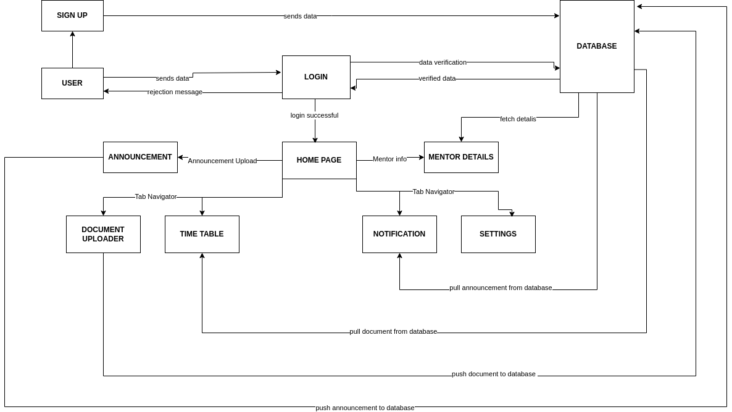

Fig 1.1 Data Flow Diagram

Referring to Fig 1.1, you can see the various processes that happen in our app. When our users navigate to our home page, they are presented with numerous options as to what they want to do next. Each option has its own flow according to which either the data is fetched or stored.

**Technological Stack**

## Frontend Development:

**React Native:** React Native would be a natural choice for developing mobile applications. It allows you to reuse code and skills across web and mobile platforms.

**Expo Asset Library (Expo Managed Workflow):** Using the Expo Asset Library to handle images and other static assets. Expo provides APIs for accessing and caching assets stored locally or remotely, which can be useful for displaying images fetched from Firebase Storage.

## Backend Development:

**Node.js:** Node.js for the backend, as it's a lightweight and efficient runtime environment for JavaScript.

**Express.js:** Express.js for web applications, it can also serve as the backend framework for your mobile app. Express.js simplifies routing and middleware integration, making it suitable for building APIs to interact with your mobile frontend.

**Firebase Storage:** Firebase Storage is a cloud storage service that allows you to store and serve user-generated content such as images, videos, and other files. It provides secure and scalable storage with built-in security rules for access control.

## Database:

**Firebase Realtime Database:** Firebase Realtime Database can be a good choice for storing and syncing data in real time. It's a NoSQL cloud database that offers low-latency access to data and seamless integration with mobile apps.

## APIs and Middleware:

**Firebase Authentication:** Firebase Authentication for user authentication and authorization. It provides secure authentication methods like email/password, social logins, and JWT-based authentication.

**Firebase Cloud Functions:** For serverless backend logic, Firebase Cloud Functions allow you to run JavaScript functions in response to Firebase events, such as database changes or HTTP requests. You can use Cloud Functions to perform tasks like data validation, sending notifications, or integrating with third-party APIs.

# Data Structures

In the application's architecture, Firebase Realtime Database serves as the primary data storage mechanism. It employs a JSON-like structure, facilitating the organization of data into a tree-like hierarchy of key-value pairs. This structure allows for efficient storage and retrieval of various types of information crucial for the application's functionality. User information, announcements, and potentially other application-related data are stored within this database, enabling seamless access and manipulation of data across the application.

Arrays play a pivotal role in organizing and managing specific components of the application. For instance, within the community feature, blog posts are structured and stored as arrays. This approach ensures that blog posts can be efficiently managed and displayed using mechanisms such as the map function. Similarly, challenges within the application are managed through arrays, enabling systematic storage and retrieval of challenge-related data. Arrays provide an ordered collection of elements, facilitating the handling of multiple items in a structured manner.

Moreover, objects are utilized to track and manage votes within the application. By employing objects, the application can associate specific keys, such as "yes" or "no," with corresponding values, such as vote counts. This key-value pair structure offered by objects enables efficient vote counting and management, contributing to the seamless functioning of features reliant on user voting.

# Algorithms

**User Authentication:** Authentication mechanisms typically involve algorithms for hashing passwords, verifying user credentials, and generating and validating authentication tokens. Common algorithms include bcrypt for password hashing, JWT for token-based authentication, and cryptographic hashing algorithms like SHA-256.

**Real-time Communication:** Real-time communication often relies on protocols like WebSocket, which employ algorithms for establishing and maintaining persistent connections between clients and servers. These algorithms manage message routing, delivery, and synchronization in real-time. **Data Validation Mechanisms:** Data validation involves algorithms for verifying the integrity and correctness of user inputs and database transactions. These algorithms may include regular expressions for pattern matching, algorithms for parsing and validating data structures, and algorithms for sanitizing inputs to prevent injection attacks.

**Firebase Database Operations:** Firebase database operations may involve algorithms for efficient data storage, retrieval, indexing, and querying. Firebase likely employs various algorithms under the hood to optimize database performance, such as B-trees for indexing, hashing algorithms for key-value storage, and query optimization algorithms.

**Document Upload:** The document upload functionality may involve algorithms for file handling, such as algorithms for reading, writing, and transmitting files efficiently. Additionally, there may be algorithms for file compression and decompression to optimize storage and bandwidth usage.

**Data Storage and Retrieval:** Algorithms for data storage and retrieval are essential for efficient database operations. Depending on the database technology used (e.g., MongoDB), these algorithms may include indexing algorithms, query optimization algorithms, and data compression algorithms.

# Design

## Activity Workflow Diagram

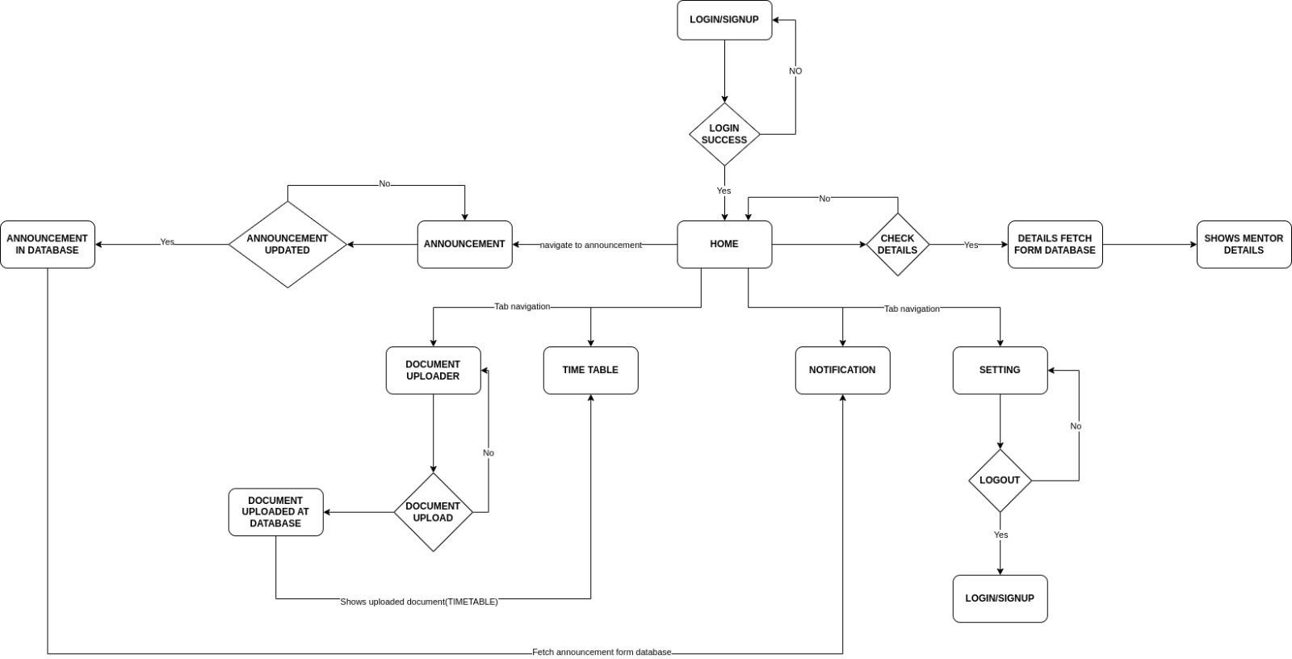

Fig 1.2 Activity Workflow Diagram

Referring to Figure 1.2, the activity workflow diagram for the Mentor-Matrix app represents the core functionalities and data flow of the Mentor-Matrix app, which is designed to help users create and complete challenges or goals. The workflow can be segmented into the following stages:

**Login/Signup:** Users can log in or create a new account to access the app.

**Home Page:** The home page serves as the central hub, providing access to various features and functionalities.

**Announcement:** The announcement button can be used by Mentor or Admins to post an announcement.

**Mentor Details:** It shows details about mentors.

**Document Uploader:** It can only be accessed by Mentors and Admins to upload documents.

**Time Table:** The timetable page shows the timetable of the student.

**Notification:** This page shows every notification posted by Mentors and Admins.

# Use Case Diagram

Fig 1.3 Use Case diagram

Referring to Figure 1.3, the use case diagram for the Mentor Matrix app involves three actors:

**Students:** These are the individual users of the Mentor Matrix app who create their account and use the app

**Mentors:** This actor can use all the functionality of the app along with creating announcements and uploading documents

# Output Screens

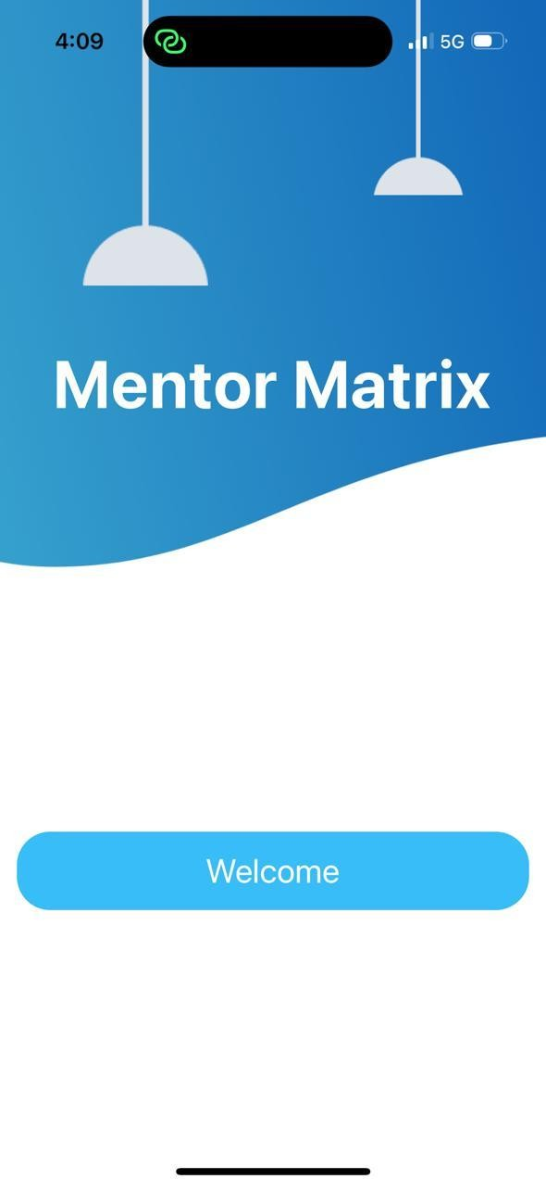

Fig 2.1 Welcome page

Welcome Screen: The Welcome Screen, depicted in Fig. 2.1, serves as the central hub for users to login or signup

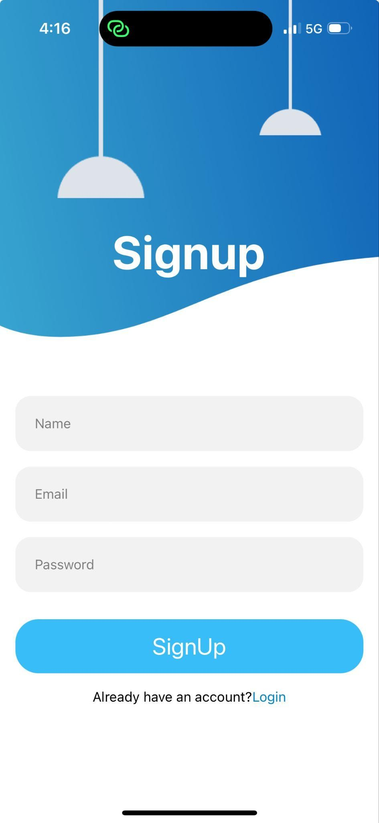

Fig 2.2 Login page

Login/SignUp screen: As shown in Fig. 2.2, the Login/SignUp screen allows users to authenticate themselves or create a new account to access the Mentor-Matrix app.

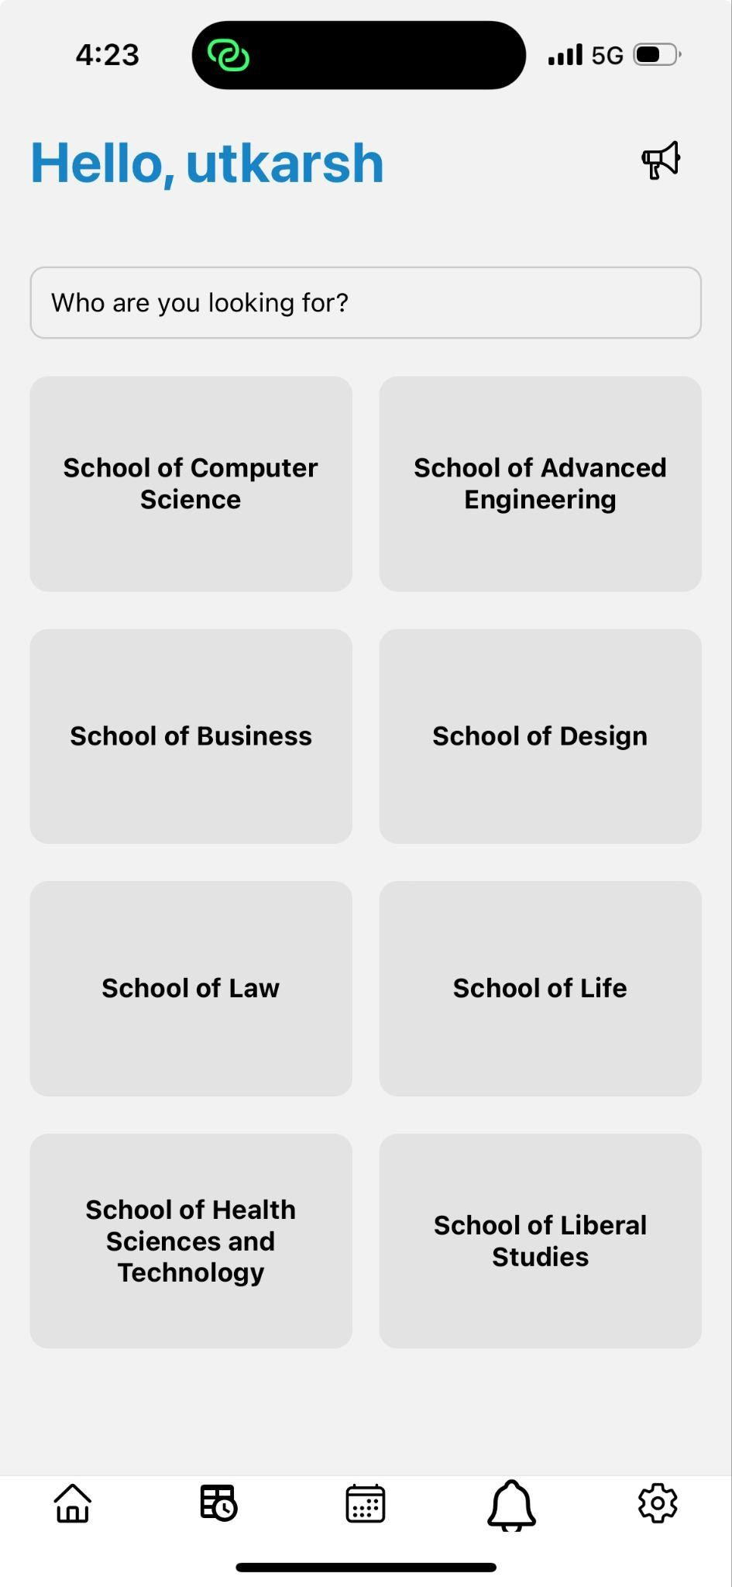

Fig 2.3 Landing page

Landing Screen: Fig. 2.3 illustrates the Landing Screen, which acts as the initial entry point for users to explore the Mentor-Matrix app's features.



Fig 2.4 Mentor List Screen

Mentor List Screen: Users can search for a Mentor on the Mentor List Screen, as shown in Fig. 2.4.

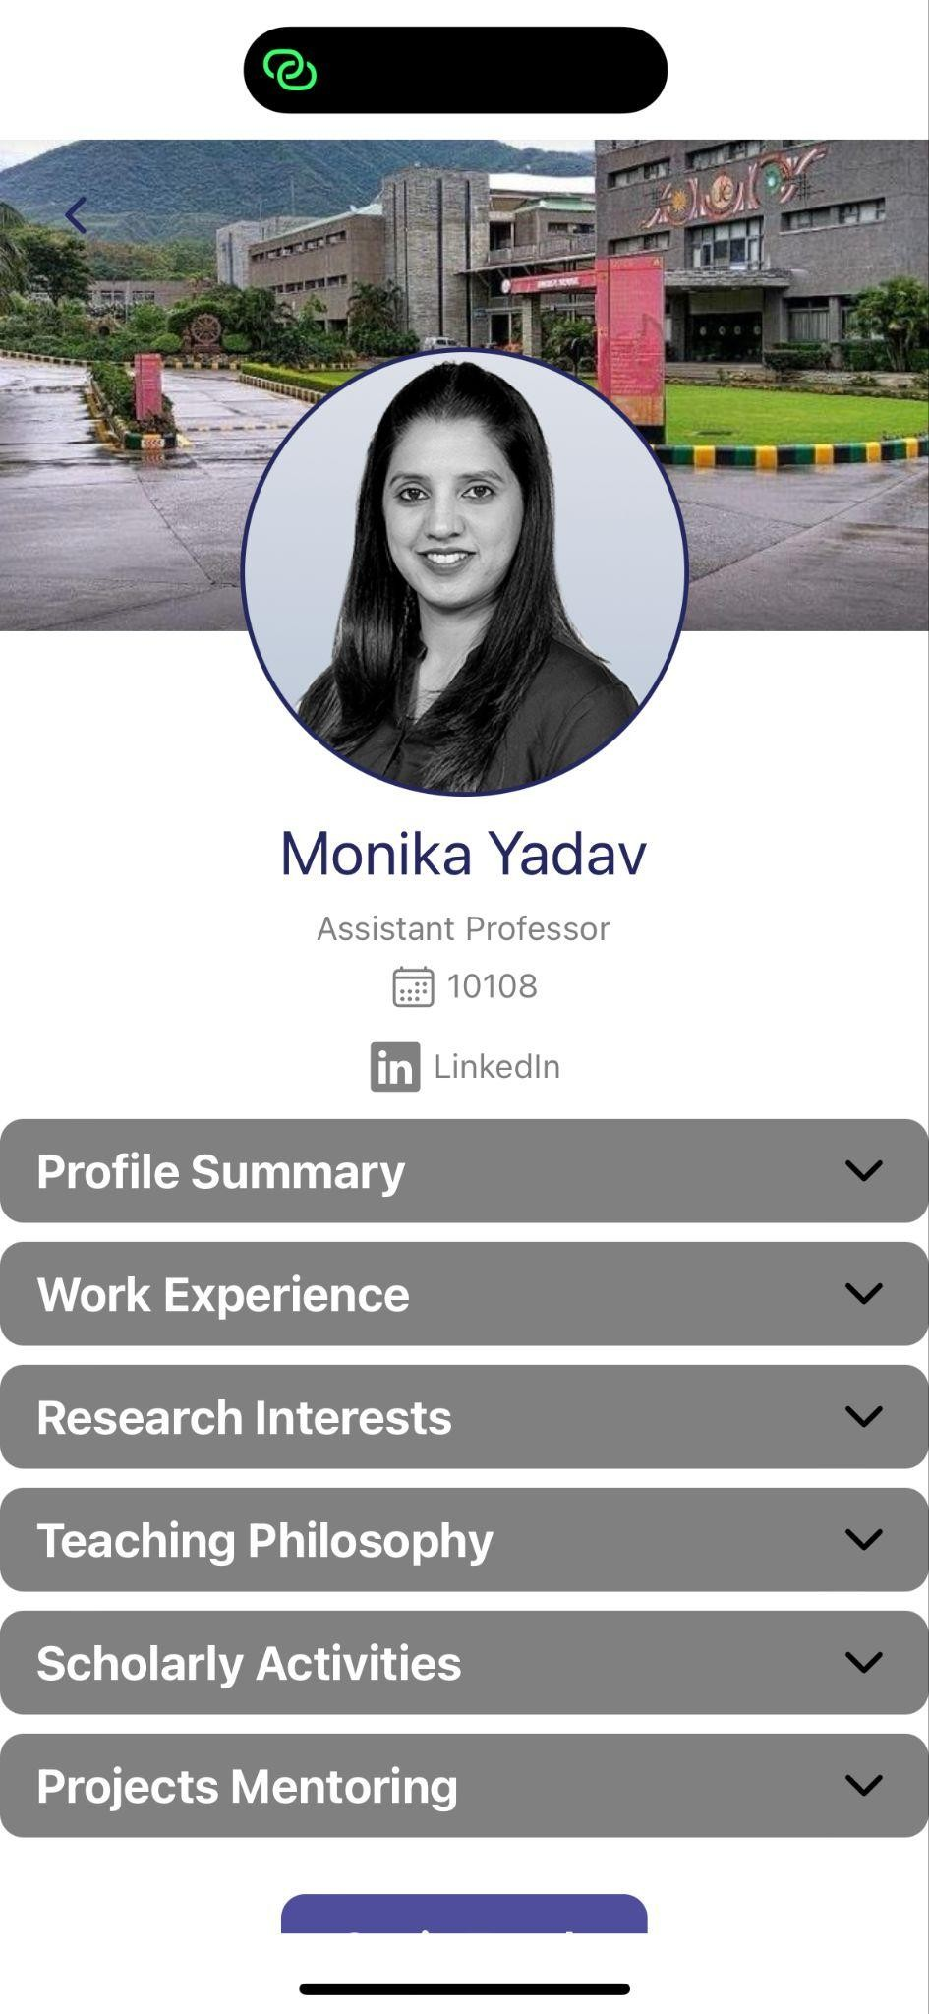

Fig 2.5 Mentor Detail Screen

Mentor Detail Screen: Users can see Mentor details and Current working project on the Mentor Detail Screen, as shown in Fig. 2.5.



Fig 2.6 Schedule

Schedule: The Schedule, shown in Fig. 2.6, this page shows schedule of Mentor

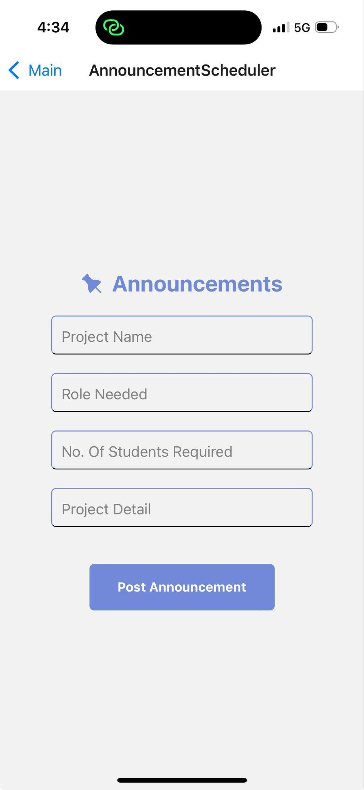

Fig 2.7 Announcement page

Announcement page: Fig. 2.7 This page is used to upload announcement and can only be posted by mentors.

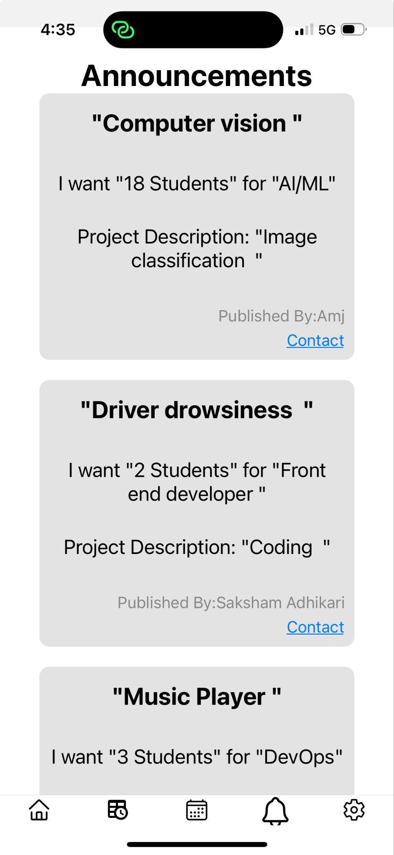

Fig 2.8 Notification page

Notification page: Fig. 2.8 This page is used to show announcements made by Mentors and Admins.

# Application Areas

The Mentor Matrix project is designed for application in the field of education. It aims to bridge the gap between students and teachers by creating a user-friendly web portal that facilitates effective mentoring relationships. This can be implemented in various educational settings, including:

Schools: Mentor Matrix can connect students with experienced teachers within their school or even across different schools in a district, providing additional support and guidance.

Higher Education: Universities and colleges can utilize Mentor Matrix to connect students with professors, teaching assistants, or even industry professionals for mentorship opportunities, enriching their academic and career development.

Online Learning Platforms: Online learning platforms can integrate Mentor Matrix to provide students with access to mentors who can offer personalized support and guidance, enhancing the overall learning experience.

By creating a more structured and efficient way to connect students and mentors, Mentor Matrix has the potential to improve educational outcomes in various educational settings.

# SWOT Analysis

### Strengths:

Innovative Concept: The app addresses a common problem (procrastination) with a unique approach, attracting users seeking effective solutions.

Utilization of Modern Technologies: Leveraging JavaScript, React.js, Node.js, and MongoDB/Firebase ensures the app's compatibility with contemporary web development standards, providing a robust and scalable platform.

User-Friendly Interface: With React.js, the app can offer a dynamic and responsive user interface, enhancing user experience and engagement.

### Weaknesses:

Initial Learning Curve: Users unfamiliar with the app may face challenges in understanding its features and functionalities, potentially leading to lower adoption rates initially.

Dependency on Internet Connection: As a web app, its functionality may be limited in areas with poor or no internet connectivity, affecting user accessibility and usability.

### Opportunities:

Market Expansion: The app has the potential to attract a broad user base beyond its initial target audience, including students, professionals, and individuals seeking self-improvement.

Integration with Productivity Tools: Collaborating with existing productivity tools or platforms (e.g., calendars, task managers) could enhance the app's functionality and user value proposition.

### Threats:

Changing User Preferences: User preferences and trends in productivity tools may shift over time, requiring the app to continuously adapt and innovate to remain competitive.

Regulatory Compliance: Compliance with data protection regulations (e.g., GDPR) and privacy laws are essential, as non-compliance could lead to legal issues and reputational damage.

# PERT chart

**References**

# [h t t p s : / / w w w . m e n t o r c i t y . c o m /](https://www.mentorcity.com/) [h t t p s : / / w w w . m i c r o m e n t o r. o r g /](https://www.micromentor.org/)